**PATIENT EDUCATION:**

**General Information:**



**1. Oral Hygiene Basics:**

**Brushing:**

* Brush twice daily for 2 minutes. Aim for consistent morning and evening routines, using a timer to ensure proper duration.
* Choose a soft-bristled toothbrush:

This protects your gums while effectively removing plaque. Replace your brush every 3 months or sooner if bristles become frayed.

* Angle your brush at 45 degrees: This reaches the gum line, where plaque accumulates and contributes to gum disease. Use small, circular motions, gently brushing each tooth surface (front, back, chewing) for at least 5-10 seconds.
* Focus on specific areas: Pay extra attention to hard-to-reach areas like the backs of your front teeth, the insides of your molars, and along the gum line.
* Don't forget your tongue! Brushing your tongue removes bacteria and helps freshen breath. Use a gentle brush stroke or a tongue scraper.



**Flossing:**

* Floss once daily: This removes plaque and food particles between teeth, where brushing alone can't reach.
* Use about 18 inches of floss: Wrap the ends around your middle fingers, leaving a 1-2 inch section taut for flossing.
* Glide the floss gently between teeth: Use a sawing motion and curve around each tooth to reach below the gum line. Avoid harsh snapping, which can irritate your gums.
* Consider alternative tools: If flossing is difficult, ask your dentist about interdental brushes or water flossers.

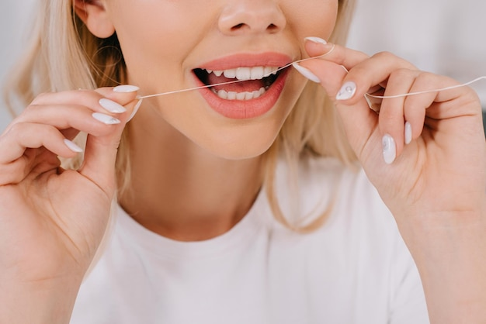

**Mouthwash:**

* Talk to your dentist about the right type for you: Antiseptic mouthwashes can kill bacteria, while fluoride mouthwashes strengthen tooth enamel. Some mouthwashes combine both benefits.
* Use mouthwash after brushing and flossing, but not instead: Rinsing immediately after brushing can wash away beneficial fluoride. Swish for 30 seconds and then spit, avoiding swallowing.



**Diet:**

* Limit sugary and acidic foods and drinks: These can erode tooth enamel and contribute to cavities. Choose water, unsweetened tea, and healthy snacks like fruits and vegetables.
* Be mindful of hidden sugars: Many processed foods and beverages contain added sugars, so check labels carefully.
* Eat a balanced diet: Include plenty of fruits, vegetables, whole grains, and lean protein. These foods provide essential nutrients for healthy teeth and gums.



**Tobacco and Alcohol:**

* Avoid smoking: Smoking can stain teeth, irritate gums, and increase the risk of oral cancer.
* Limit alcohol consumption: Excessive alcohol can also contribute to oral health problems.

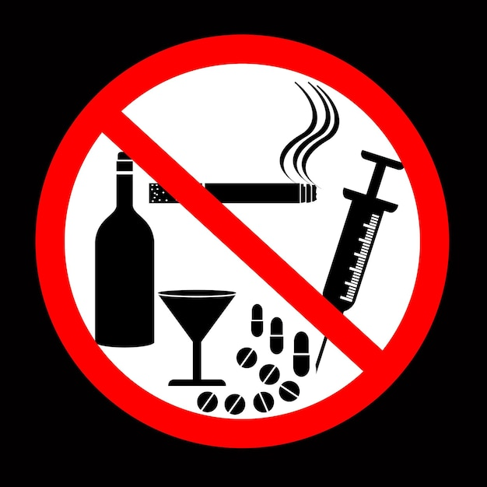

**Additional Tips:**

Visit your dentist regularly for checkups and cleanings: This helps prevent problems and ensures early detection of any issues.

Replace your toothbrush regularly: Worn-out bristles are less effective at removing plaque.

Make oral hygiene a family activity: Brush and floss together as a family to encourage healthy habits for everyone.

Find a fun brush and toothpaste: Choose a brush you enjoy using and a toothpaste with a flavor you like.

Use a timer or app: This can help you stay on track and ensure you brush for the recommended time.

By following these tips and establishing a consistent oral hygiene routine, you can achieve and maintain a healthy, confident smile!

**2. Importance of Regular Dental Checkups:**

Schedule checkups and cleanings every 6 months for early detection and prevention of dental problems.

Regular cleanings remove plaque and tartar buildup that brushing and flossing alone cannot reach.

Dentists can identify and address potential issues like cavities, gum disease, and oral cancer at an early stage, often before symptoms appear.



**Why 6 Months?**

* Plaque and tartar buildup can occur within 6 months, leading to potential problems if left unchecked. Regular cleanings remove these deposits before they harden and become more difficult to remove.
* Early detection and intervention for dental issues are crucial for successful treatment and preventing complications. Regular checkups allow dentists to identify problems early, often before symptoms appear, when treatment is easier and more effective.

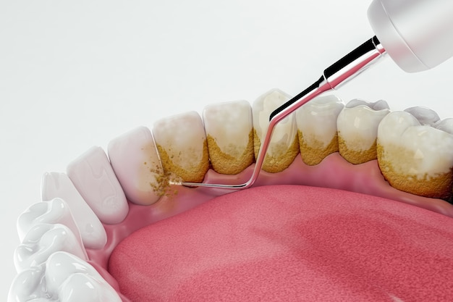

**Beyond the Basics:**

* Comprehensive Examinations: Regular checkups include not just cleanings but also thorough examinations of your teeth, gums, tongue, and oral tissues. This helps identify potential problems like oral cancer, jaw joint issues, and signs of systemic diseases that can manifest in the mouth.
* Personalized Care: Dentists can tailor your dental care based on your individual needs and risk factors. This may include recommendations for specific brushing and flossing techniques, dietary modifications, or preventive treatments like fluoride applications or sealants.
* Monitoring Existing Conditions: For individuals with existing dental problems like gum disease or cavities, regular checkups allow dentists to monitor progress and adjust treatment plans as needed to ensure optimal oral health.

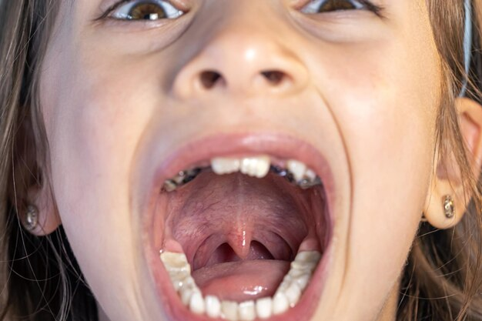

**Benefits of Early Detection:**

* Minimizing Pain and Discomfort: Addressing issues early can prevent them from progressing to painful stages, requiring more extensive and potentially uncomfortable treatment.
* Preserving Teeth and Bones: Early intervention can save teeth from cavities and gum disease, preventing tooth loss and bone loss around the teeth.
* Lowering Treatment Costs: Addressing problems early often requires less complex and expensive treatment compared to advanced stages.
* Maintaining Overall Health: Oral health is linked to overall health. Regular dental care can help prevent systemic health problems like heart disease, stroke, and diabetes.

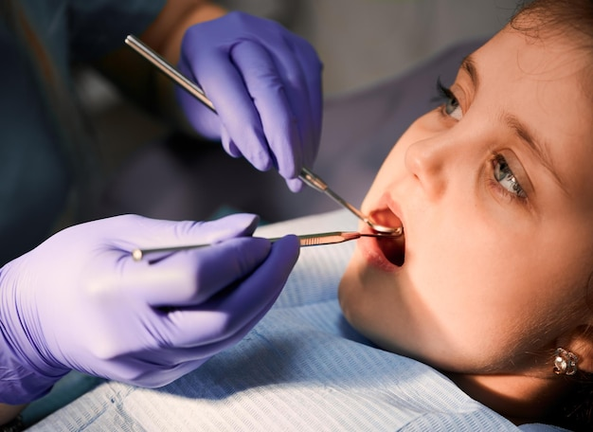

**Making Checkups Accessible:**

* Discuss any financial concerns with your dentist. Many offer flexible payment plans or accept insurance.
* Consider scheduling appointments during convenient times, such as evenings or weekends.
* Talk to your dentist about any anxiety you may have regarding dental visits. They can provide strategies to make your experience more comfortable.

Remember, regular dental checkups are an investment in your oral health and overall well-being. By prioritizing these appointments, you can maintain a healthy smile and contribute to your long-term health.

**3. Common Warning Signs of Oral Health Issues:**

**Toothache:**

Persistent or severe pain can indicate a cavity, abscess, or other problem.

Sensitivity: Pain or discomfort when exposed to hot, cold, sweet, or acidic foods or drinks can indicate enamel erosion or tooth decay.



**Bleeding gums:**

Red, swollen, and bleeding gums are signs of gingivitis, an early stage of gum disease.

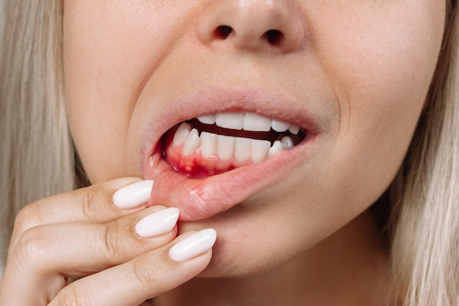

**Bad breath:**

Persistent bad breath can be caused by poor oral hygiene, gum disease, or other medical conditions.



**Loose teeth:**

Teeth that wiggle or feel loose are a sign of advanced gum disease or bone loss.

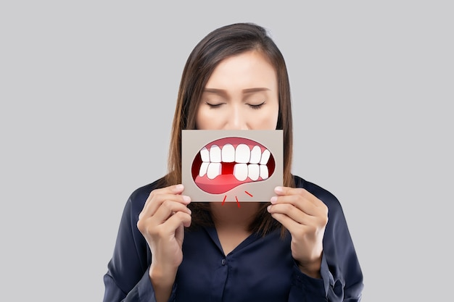

**White or red patches in the mouth:**

Unusual patches or sores on the tongue, cheeks, or gums could be signs of oral cancer and should be checked by a dentist immediately.

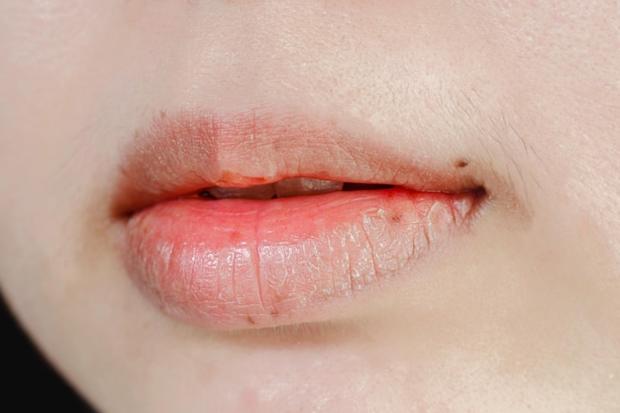

**4. Dental Emergency Situations:**

* Severe pain that does not subside with over-the-counter medication.
* Facial swelling or difficulty swallowing.
* Uncontrolled bleeding from the mouth.
* Knocked-out or fractured teeth.
* Abscess (a pus-filled bump on the gum).
* Any sign of potential oral infection.
* If you experience any of these emergency situations, seek immediate professional help from your dentist or visit the nearest emergency department.



**Specific Issues:**

**1. Toothaches:**

Causes: Cavities, abscesses, impacted teeth, gum disease, trauma.

Home remedies: Over-the-counter pain medication like ibuprofen or acetaminophen, saltwater rinses (teaspoon of salt in a glass of warm water), cold compresses applied to the outside of the cheek.

When to see a dentist: If pain persists for more than 24 hours, worsens, is accompanied by fever or swelling, or interferes with daily activities.

**2. Gum Disease:**

**Stages:**

Gingivitis (mild inflammation): Red and swollen gums that bleed easily.

Periodontitis (bone loss): Gum recession, loose teeth, and increased tooth sensitivity.

Advanced periodontitis: Significant tooth loss and potential jawbone damage.

Symptoms: Bleeding gums, bad breath, red and swollen gums, pus around teeth, loose teeth.

Treatment: Professional cleaning (scaling and root planning), antibiotics in some cases, surgery in severe cases.

Prevention: Good oral hygiene, regular dental visits, quitting smoking.

**3. Sensitive Teeth:**

Causes: Enamel erosion, receding gums, tooth decay.

Home remedies: Desensitizing toothpaste, fluoride rinse, avoiding hot and cold foods and drinks.

When to see a dentist: If sensitivity interferes with daily activities or does not improve with home remedies.

Treatment: Professional fluoride application, bonding, crowns.

**4. Cavities:**

Causes: Plaque buildup from sugary and acidic foods and drinks.

Symptoms: Toothache, sensitivity, discoloration (brown or black spots), visible holes in teeth.

Treatment: Fillings, crowns, root canals in severe cases.

Prevention: Good oral hygiene, regular dental visits, limiting sugary and acidic foods and drinks, drinking fluoridated water.

**5. Wisdom Teeth:**

Symptoms: Pain, swelling, difficulty chewing, bad breath.

Treatment: Extraction if necessary, typically recommended if causing pain or impacting other teeth.

Prevention: Regular dental monitoring for potential impaction issues.

**Additional Resources for Patient Education:**

American Dental Association (ADA):

<https://www.ada.org/>

National Institute of Dental and Craniofacial Research (NIDCR):

<https://www.nidcr.nih.gov/>

Mouth Healthy:

<https://www.mouthhealthy.org/>